Redcap

1. Insert database schema

Through Designer/Data dictionary to create instruments and variables inside them

Online designer:

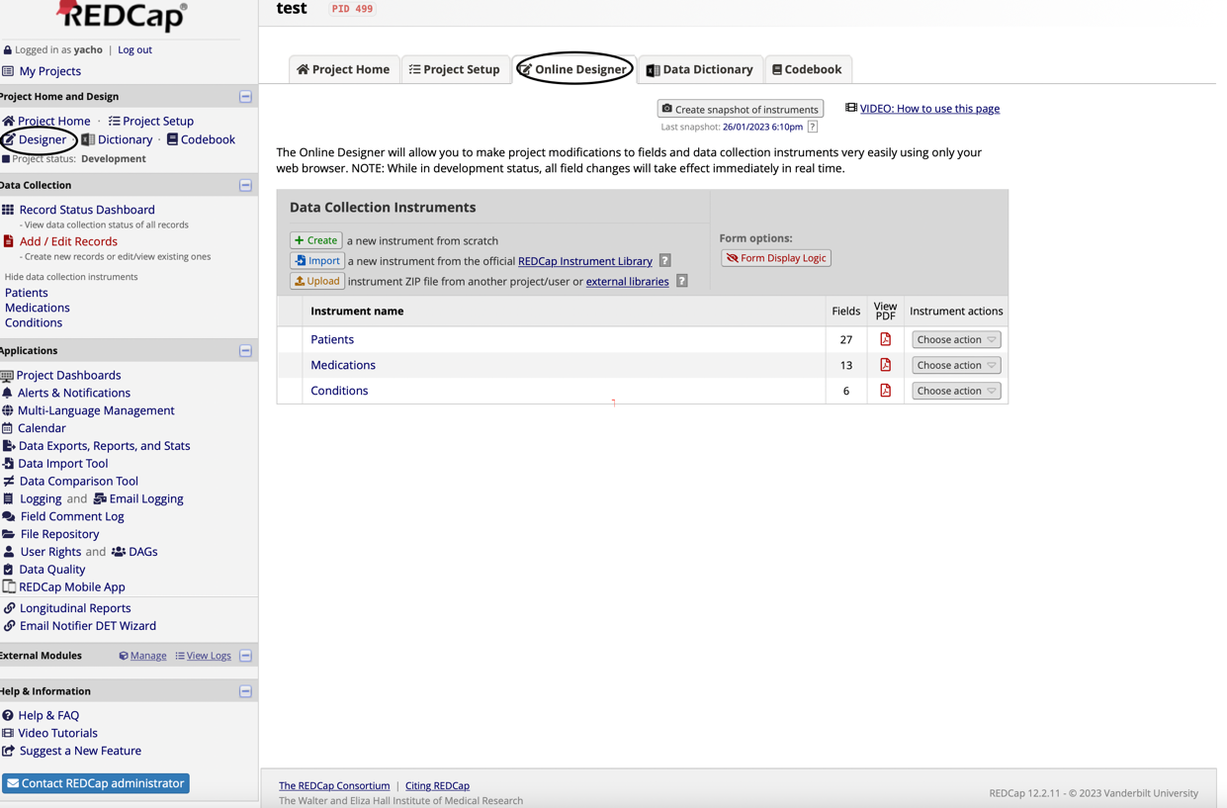

Click  to create a new instrument and inside each instrument can 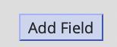 lead to the window shown below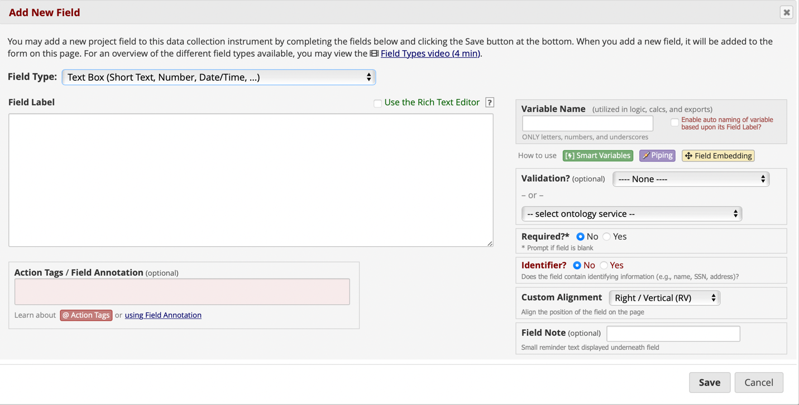

* Filed type: type of the data
* Filed label: detail about the data, in survey shown as the question asked
* Variable name: column name of the instrument
* Required?: is about whether this data can leave as blank

Note: for datetime, we can add validation

Or download the current data dictionary to fill in added information and upload the new data dictionary.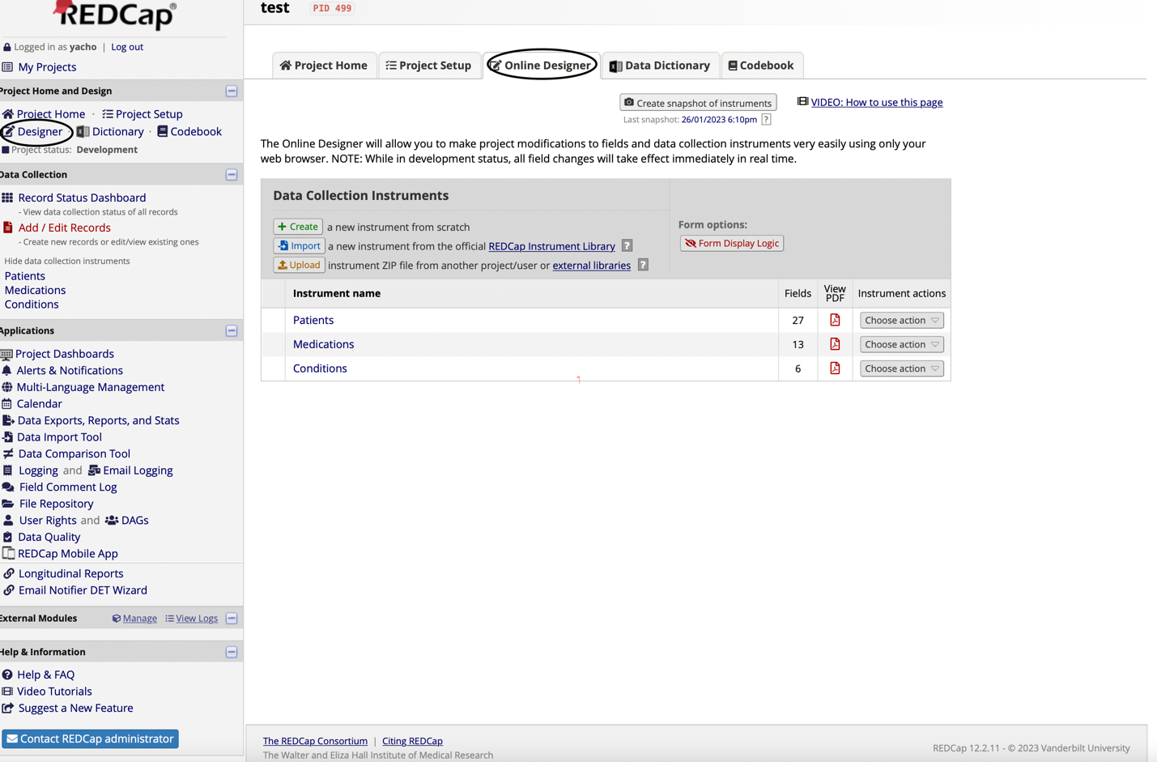

In codebook, it can have an overview on the generated instrument and fields

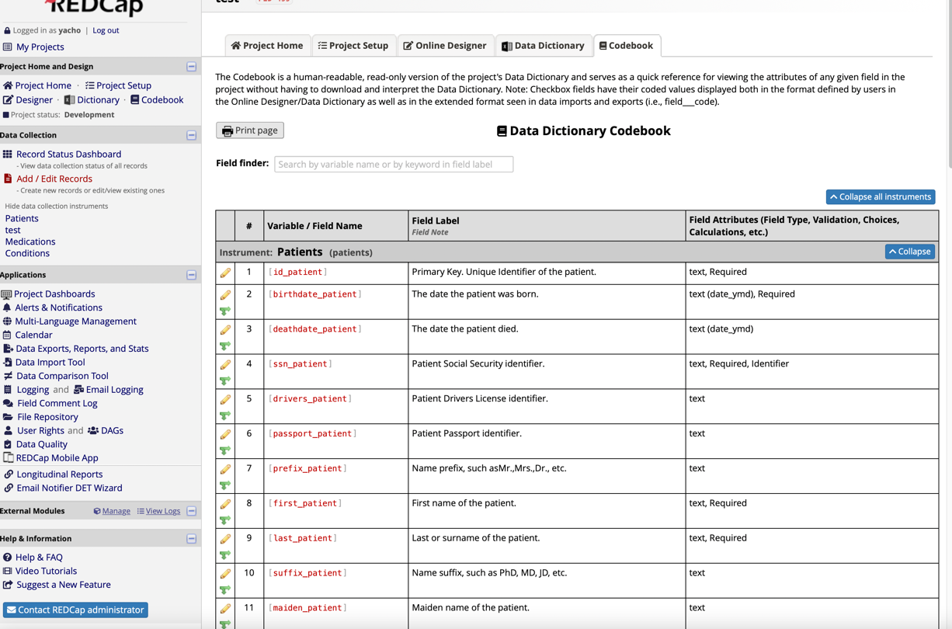

1. Import data (for CSV file it could be through Data import Tool) generally, download the template file, fill the data into that template file, and submit the filled file, if the CSV file is too large, it is required to split into smaller CSV files to upload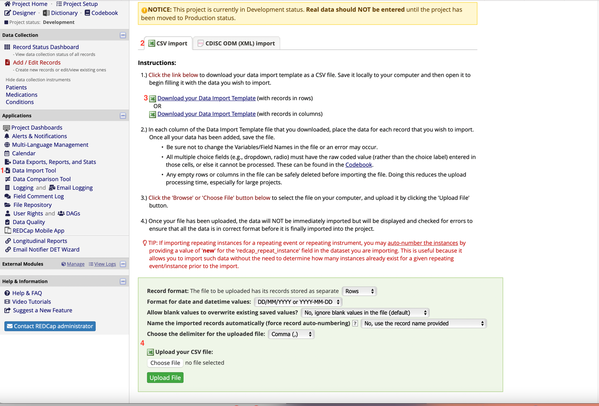

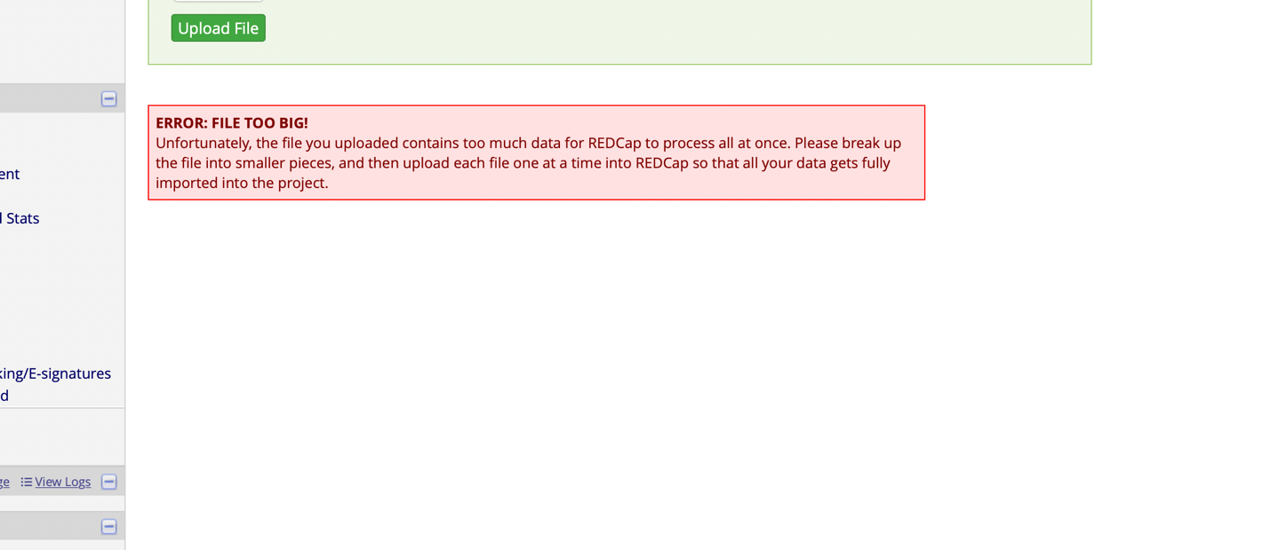

For our case, as a patient can have multiple conditions and medications, we need to change the project setup to allow repeatable instruments, so that each patient id could relate to multiple conditions and medications

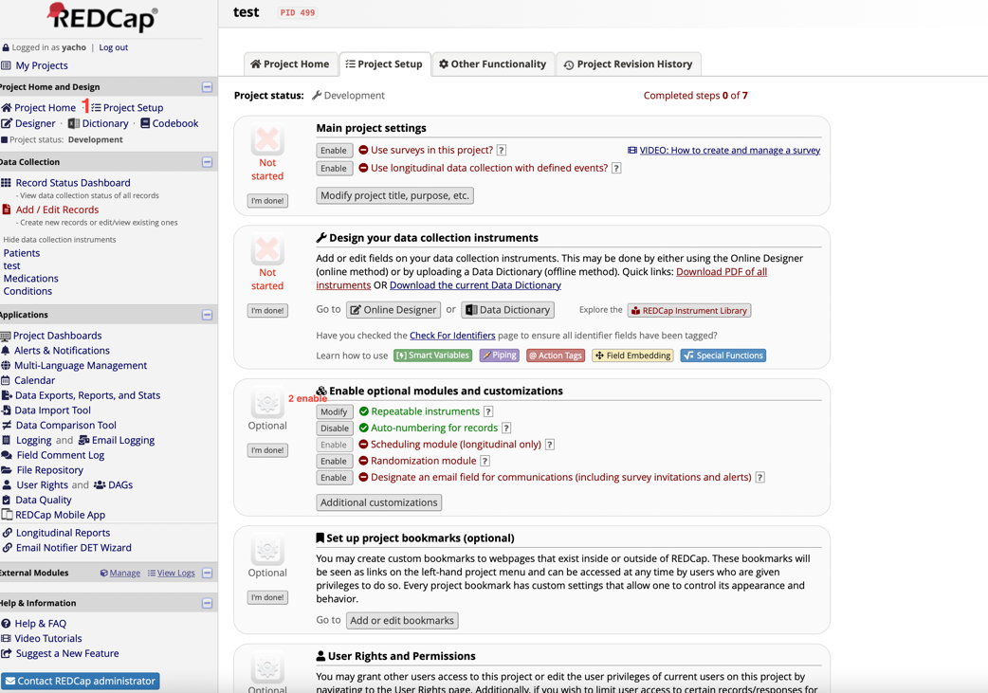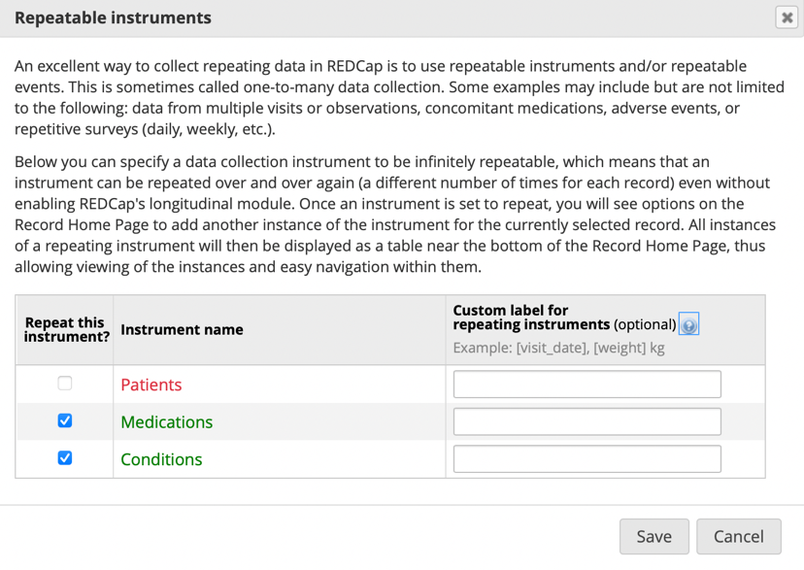

Note: when importing the dataset with repeating instances for the instrument, we found that there are two more columns (redcap_repeat_instrument, redcap_repeat_instance) in Data import Template.

The redcap_repeat_instance can set as ‘new’, while the redcap_repeat_instrument need to be all lowercase which is aligned to the instrument name in the Data dictionary Codebook

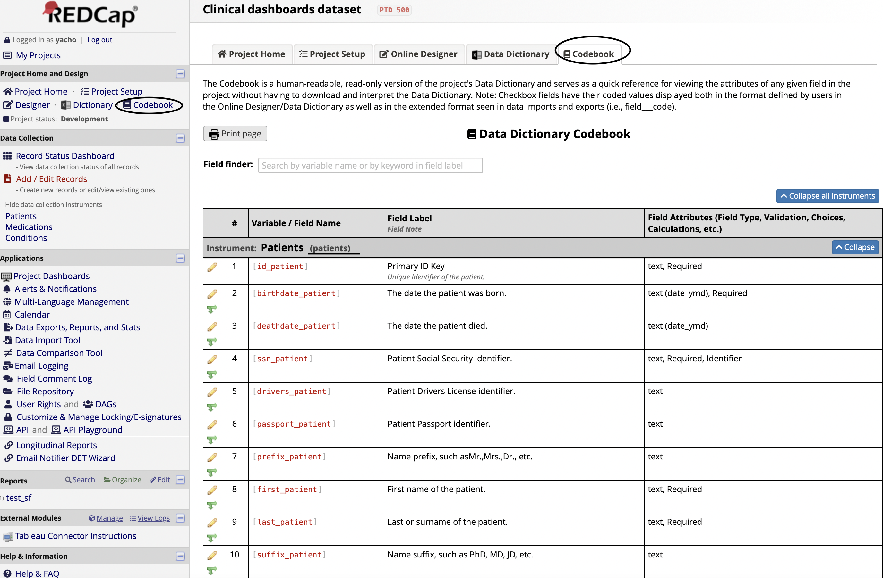

API utilization in redcap

Doc: <https://redcap.wehi.edu.au/api/help/?view=security>

1. Get API token

Ensure the security of the utilization od redcap API, for every redcap request, it required for each user a API token provided to connect the specific project of the redcap databse, the nour first step is to go to the API in the sidebar under Application to ask an API token generated.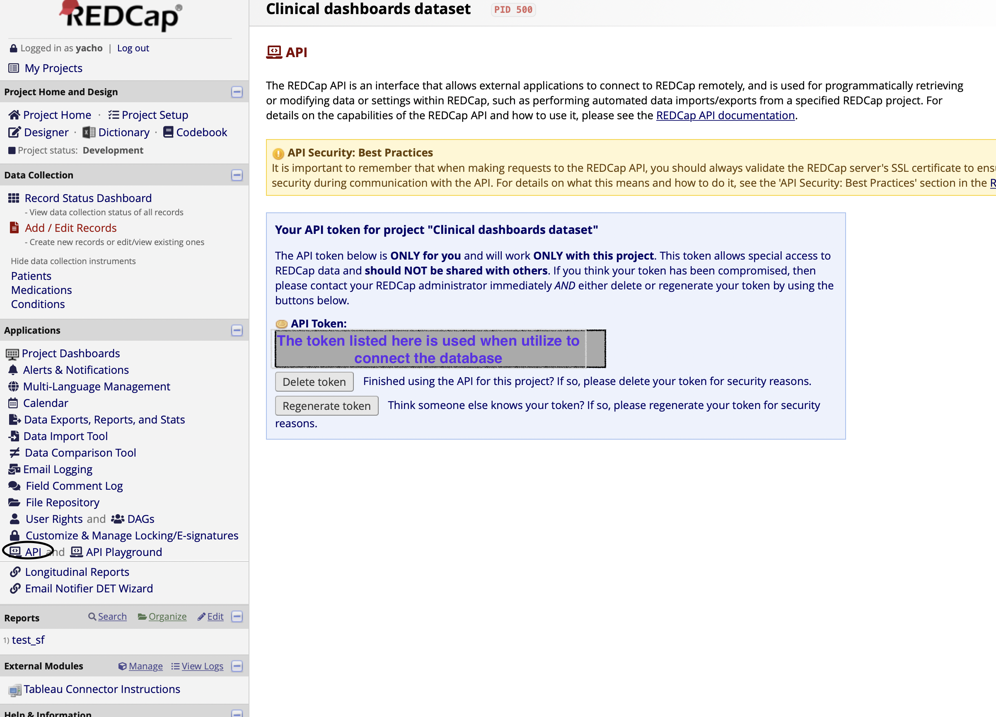

1. Then you could go through the detail in API playground to explore the usage pf the redcap API in different programming language

